Earliest Deadline First (EDF)
# Source: AI Source: Provided by: [Data Path: Persons Table -> ID Column: 1, Name_En Column: Motasem Essam] -> From: [ChatGPT] on [1/21/2026]
Earliest Deadline First (EDF) is one of the most widely used dynamic scheduling algorithms in Real-Time Systems (RTS). Unlike RMS, which is static, EDF assigns priorities at runtime based on task deadlines.

Definition
# Source: AI Source: Provided by: [Data Path: Persons Table -> ID Column: 1, Name_En Column: Motasem Essam] -> From: [ChatGPT] on [1/21/2026]
EDF is a dynamic priority scheduling algorithm in which:
- The task with the earliest (closest) deadline is given the highest priority.
- Priorities can change at runtime as new tasks arrive or deadlines approach.
- It is optimal for scheduling periodic and aperiodic tasks on a single processor, meaning if a feasible schedule exists, EDF will find it.

Key Features
# Source: AI Source: Provided by: [Data Path: Persons Table -> ID Column: 1, Name_En Column: Motasem Essam] -> From: [ChatGPT] on [1/21/2026]
- Dynamic Priority: Task priorities are calculated continuously based on deadlines.
- Supports Periodic and Aperiodic Tasks: Can handle unpredictable or irregular task arrivals.
- Preemptive: A task with a closer deadline can preempt a running task.
- Optimal for CPU Utilization: Can utilize up to 100% CPU for schedulable tasks, unlike RMS.

Advantages
# Source: AI Source: Provided by: [Data Path: Persons Table -> ID Column: 1, Name_En Column: Motasem Essam] -> From: [ChatGPT] on [1/21/2026]
- Flexible: Handles dynamic workloads efficiently.
- Optimal: Guarantees that all deadlines are met if total utilization ≤ 100%.
- Supports Mixed Tasks: Works for periodic and aperiodic tasks simultaneously.

Disadvantages
# Source: AI Source: Provided by: [Data Path: Persons Table -> ID Column: 1, Name_En Column: Motasem Essam] -> From: [ChatGPT] on [1/21/2026]
- Runtime Overhead: Continuously calculating priorities can increase CPU load.
- Less Predictable: Harder to analyze in complex systems with multiple processors.
- Not Ideal for Resource-Sharing: Needs extra mechanisms to prevent priority inversion when tasks share resources.

Example
# Source: AI Source: Provided by: [Data Path: Persons Table -> ID Column: 1, Name_En Column: Motasem Essam] -> From: [ChatGPT] on [1/21/2026]
Suppose we have three tasks arriving at the same time:
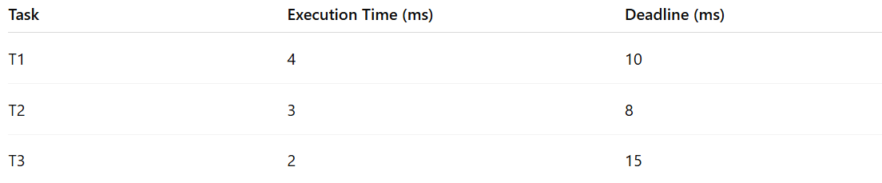
Task | Execution Time (ms) | Deadline (ms)
T1 | 4 | 10
T2 | 3 | 8
T3 | 2 | 15
- EDF Scheduling Order: T2 → T1 → T3
- Task with closest deadline (T2, 8 ms) executes first, then T1, and finally T3.
- If a new task arrives with a deadline sooner than the currently running task, it preempts the current task.

Why EDF Matters for Software Engineers
# Source: AI Source: Provided by: [Data Path: Persons Table -> ID Column: 1, Name_En Column: Motasem Essam] -> From: [ChatGPT] on [1/21/2026]
- Used in adaptive and dynamic real-time systems, like robotics, multimedia, and networked systems.
- Teaches deadline-driven scheduling and real-time task management.
- Ensures maximum CPU utilization while meeting deadlines.

